# IMPLEMENTATION OF SQL QUERY CONSTRUCTION TO IMPROVE DATABASE CONCEPT UNDERSTANDING WITH CLOSE-ENDED APPROACH

**UNDERGRADUATE THESIS PROPOSAL**

## Arranged By:

**Muhammad Ilham Adhim NIM. 1841720076**



**INFORMATICS ENGINEERING STUDY PROGRAM DEPARTMENT OF INFORMATION TECHNOLOGY STATE POLYTECHNIC OF MALANG**

**2020**

**LETTER OF APPROVAL**

**IMPLEMENTATION OF SQL QUERY CONSTRUCTION TO IMPROVE DATABASE CONCEPT UNDERSTANDING WITH CLOSE-ENDED APPROACH**

**Arranged By:**

**MUHAMMAD ILHAM ADHIM NIM. 1841720076**

**This undergraduate thesis proposal has been tested in**

4th February 2022

**Approved by:**

|  |  |  |  |  |
| --- | --- | --- | --- | --- |
| 1. | Supervisor | : | Putra Prima Arhandi, S.T., M.Kom. NIP. 19861103 201404 1 001 |  |
|  |  |  | ........................... |
| 2. | Reviewer I | : | Mustika Mentari S.Kom., M.Kom  NIP. 198806072 019032 016 |  |
|  |  |  | ........................... |
| 3. | Reviewer II | : | Agung Nugroho Pramudhita, ST., MT.  NIP. 198902102 019031 020 |  |
|  |  |  | ........................... |

Ascertain,

|  |  |
| --- | --- |
| Head of Information Technology Department | Head of Informatics Engineering Study program |
| Rudy Ariyanto, S.T., M.Cs. | Imam Fahrur Rozi, S.T., M.T.  NIP. 19840610 200812 1 004 |
| NIP. 19711110 199903 1 002 |

# Table of Contents

LIST OF FIGURES iv

LIST OF TABLES v

CHAPTER I. INTRODUCTION 1

* 1. Background 1
  2. Research Problem 2
  3. Research Scope………………………………………………………………………3
  4. Objectives 3
  5. Benefits 3

CHAPTER II. LITERATURE STUDY 4

* 1. Literature Study 4
  2. Basic Theory 6
     1. Database 6
     2. SQL Query 6
     3. Drag-and-Drop 7
     4. Close-Ended Approach 7
     5. SQLearn 7

CHAPTER III. RESEARCH METHODOLOGY 10

* 1. Time and Place of Research 10
  2. Data Collection 10
     1. Field Research 10
     2. Library Research 10
  3. Data Processing 10
  4. System Design 11
     1. Use Case Diagram 11
     2. Application Activity Diagram 12
     3. Application Features 13
     4. Application Mockups 14
     5. System Architecture 16
     6. System Testing 17

CHAPTER IV. RESEARCH TIMELINE 18

REFERENCES 19

# LIST OF FIGURES

Figure 2. 1 Drag-and-Drop Model by Phewkum C. 6

Figure 2. 2 Model of end users’ query formulation processes 8

Figure 2. 3 Lecturer - Application Concept 9

Figure 2. 4 Students - Application Concept 10

Figure 3. 1 Use Case Diagram - Student 12

Figure 3. 2 Use Case Diagram - Lecturer 13

Figure 3. 3 Use Case Diagram - Admin 14

Figure 3. 4 Activity Diagram of SQLearn 15

Figure 3. 5 Mockup - Students submit the correct query 17

Figure 3. 6 Mockup - Students submit the wrong query 18

Figure 3. 7 Mockup - Lecturer create new practice 18

Figure 3. 8 System Architecture of SQLearn 19

# LIST OF TABLES

Table 1 Research Schedule 18

1

# CHAPTER I. INTRODUCTION

## Background

Programming is a fundamental skill for science and technology [(Ali et al., 2017)](https://www.zotero.org/google-docs/?ekdVVR). The awareness of programming implementation in multiple areas of expertise has made it a mandatory course in academic institutions [(Fedorenko et al., 2019)](https://www.zotero.org/google-docs/?wvYwrL). By learning computer science, students are expected to increase their creativity and improve critical thinking [(Jamil](https://www.zotero.org/google-docs/?vL9IUt) [& Isiaq, 2019)](https://www.zotero.org/google-docs/?vL9IUt). Despite its benefits, learning to program has various challenges, such as a lack of motivation to comprehend and write the codes. In addition, the high dropout rates of studying computer science, especially in programming courses, has indicated the subject as one of the hardest courses to learn [(Bennedsen & Caspersen, 2007)](https://www.zotero.org/google-docs/?pLYXD9)

Despite a high dropout rate in programming subjects, the implementation of databases is one of the valued skills in the informatics and computer science area [(Puspitasari et al., 2019)](https://www.zotero.org/google-docs/?zgBoax). In academics, the learning role of databases includes understanding the concept of databases that are relevant to industry requirements and database management [(Zhuoyi et al., 2012)](https://www.zotero.org/google-docs/?hXupYF). Learning and implementing databases is not limited to academic areas, as it affects industry operation in the process. The relevancies of databases in the industry lies in organization management, data entry, and effective data processing [(Luthfi & Ayu, 2019)](https://www.zotero.org/google-docs/?faDbgD). To increase understanding of programming courses, especially in databases, the approach that needs to be used should not only be limited to code generation, but needs to reflect the thinking process of the student, case study description, and problem-solving [(Marion et al., 2007)](https://www.zotero.org/google-docs/?gZELFA).

SQL Query Formulation can be a challenging task due to various factors, such as its declarative form of SQL syntax [(Taipalus, 2019),](https://www.zotero.org/google-docs/?IiBlkx) the query complexity that is limited to short- term memory of code writer when retrieving data [(de Jong, 2010),](https://www.zotero.org/google-docs/?L9qt3C) and potential of ambiguity in retrieving data [(Borthick et al., 2001)](https://www.zotero.org/google-docs/?0MDffI). Relational database and Structured Query Language (SQL) is still dominantly used in industry and academic fields [(Rith et al., 2014)](https://www.zotero.org/google-docs/?R9fz1n). Some queries that are most likely to occur in learning SQL are FROM, SELECT, WHERE, ORDER BY, GROUP BY, and HAVING [(Ahadi et al., 2015)](https://www.zotero.org/google-docs/?k6e00o). To make an effective query, students are required to visualize various elements within the database concept and understand how to extract such data [(Phillip Garner, 2015).](https://www.zotero.org/google-docs/?VEyLbv) Due to this reason, the SELECT clause becomes the main concept in learning SQL. Moreover, when students have learnt SQL SELECT, the transition to exploring other clauses will be faster [(Phillip Garner,](https://www.zotero.org/google-docs/?Hlbzya) [2015).](https://www.zotero.org/google-docs/?Hlbzya)

The common practice of teaching databases is mostly concerned with learning normalization techniques, SQL syntax, operating database management, and designing ERD [(Sastry, 2015).](https://www.zotero.org/google-docs/?jdZoZh) Various researches to gain a better student's understanding of database courses has done before, such as using step-by-step in the learning process (Chen & Ray, 2004), information system integration with role-playing approach [(Shaw et al., 2007)](https://www.zotero.org/google-docs/?I8ALj0), and Learning SQL with PBeL (problem-based E-Learning) evaluation [(Hoque et al., 2014)](https://www.zotero.org/google-docs/?Vd967N). However, this approach is too theoretical and does not focus on honing a student's problem-solving skills [(Sastry, 2015).](https://www.zotero.org/google-docs/?mmViNH)

SQL code construction has been implemented in the medical system, with more focus on using database concepts to make a valid SQL Query (Gorskis, 2018). The approach done on Gorskis' research was class concepts, object property concepts and data property concepts. Similar research has been done by [(Phewkum et al., 2019)](https://www.zotero.org/google-docs/?bVPpd9) in the E-Learning platform with a drag-and-drop concept. By having 30 participants contribute to it, they mentioned that the application gives new experience in learning SQL. Yet, based on the score, it is indicated that the application is not the easiest to use, and there is no further explanation on the impact of the application on students’ understanding of learning SQL. In addition, the code construction used is using an open-ended question format. As a result, even the syntax error could be minimized, students also need to consider the order of code blocks to get the correct answer.

As research develops, a close-ended approach has been widely used in data gathering. This is because of its ease of use and configuration for participants [(Baburajan et al., 2021).](https://www.zotero.org/google-docs/?XpnOn3) In a learning platform, a close-ended approach can be implemented in the teaching process or examination. This can be seen from one close-ended approach that has predefined answers. It allows students to think logically about solving case studies within the appropriate context and scope of the problem [(Lin & Lien, 2013)](https://www.zotero.org/google-docs/?dqUdwL).

Based on the mentioned background, the writer proposes research "Implementation of SQL Query Construction to Improve Database Course Understanding with Close-Ended Approach". With this research, it is expected that using a close-ended approach in the database subject may reflect students' thinking process and problem-solving skills by using SQL Code reconstruction may improve students' understanding of database concepts significantly.

## Research Problem

Based on the mentioned background, the problem statement in this research relies on How is the effect of SQL Code construction with drag-and-drop and close-ended approach on students' understanding of SQL SELECT Statements concepts?

* 1. **Research Scope**

Based on the mentioned background, problem constraints in this research according to the scope of this research are:

* + - The application runs on a web platform
    - Using MySQL database.
    - SQL queries used for SELECT statements
    - Grading and back-end process using NodeJs.
    - The application will be tested by students who have done database classes and lecturers in Information Technology Major in State Polytechnic of Malang.

## Objectives

This research aims to observe the effect of SQL code construction implementation with a drag*-and-drop* method and *close-ended* approach to students' understanding of the SQL SELECT Statements concepts.

## Benefits

The benefits of this research are as follows:

* + - Researcher, to identify whether students who are involved in learning SQL using the *drag-and-drop* and *close-ended* approach have an increased understanding of the SQL SELECT Statements concepts.
    - State Polytechnic of Malang, to make reference for further research. Especially for students that has interest on developing database learning.
    - Students, can be used to enhance understanding and experience in learning database concepts, especially in SQL queries.

# CHAPTER II. LITERATURE STUDY

## Literature Study

There are several references to support this research, one of which is research on the role of database learning and its effect on student understanding in the field of Information Science, Drag-and-Drop concepts in SQL learning, and the use of SQL Construction in non-educational and educational fields.

Research conducted by (Sastry, 2015) entitled "An Effective Approach for Teaching Database" explained that the process of learning databases should be focused on learning normalization techniques, SQL queries understanding, operating database products, and designing a comprehensive database as a one-semester curriculum. The blocker is, the learning pattern is only limited to normalizations and designing the Entity-Relationship Diagram (ERD) from time to time. Based on the conclusion of this research, one of many factors that define students’ understanding is using Problem-Based Learning in formulating SQL queries. This is because students need not do further research regarding a specific case study and focus more on giving the solution in SQL code into the system. Furthermore, flexibility when doing the assignment to get in-depth knowledge of SQL queries allows them to gain more insights on solutions available to solve the case. This allows students to discuss and collaborate and do their research on which solution suits the best based on the given case study.

Research is done by [(Heift, 2003)](https://www.zotero.org/google-docs/?835QPO) to 27 participants ranging from 19 to 26 years old and divided into 3 groups. The first group is assigned to finish an MCQ exam, the second group finishes an exam with the drag-and-drop concept, whereas the last group is given a writing exam. The result indicates that the group assigned with the drag-and-drop exam has the best performance compared to others.

Drag-and-drop concepts have been implemented in research entitled “Filling the gap in programming instruction: a text-enhanced graphical programming environment for junior high students” by [(Cheung et al., 2009)](https://www.zotero.org/google-docs/?AQIQSe). Based on its research conclusion, students can focus more on the logic required in a case study with no need to worry about syntax failure. In addition, 80% of the participants without a programming background had creative output and nearly 70% of participants felt motivated to continue to proceed with their computational subjects.

SQL code reconstruction has been implemented by (Gorskis, 2018) in his journal entitled “SQL query construction from database concepts”. It is explained that there are 3 databases

concepts, namely 'class type' – which is more based on tables and views –, 'Object Property' – which focus on the relationship among tables –, and ‘data property’ – a concept that is more focused on attributes that exist on each table –. The effective implementation of database concepts in SQL code reconstruction highly depends on the experts that understand the existing dataset structure. Therefore, from a learning perspective, the teacher and lecturer on this subject are expected to have in-depth knowledge of database concepts that is suitable for each case study so that the students can make valid SQL queries and finish the task more effectively.

In another research (Phewkum et al., 2019) entitled “Scramble SQL: A Novel, Drag-and- drop SQL Learning Tool” indicates that drag-and-drop practices in learning databases – especially SQL – has given new experience for students to solve case studies. By involving 30 participants that have done database subjects, it is concluded that they tend to have good knowledge of computer commands and enjoy the learning process with an average score of 3.90 by 5. By having an open-ended case in mind, research done by (Phewkum et al., 2019) gives options to the students to formulate the code reconstruction based solely on the students’ knowledge and creativity, which is prone to logical error even if the result is correct.

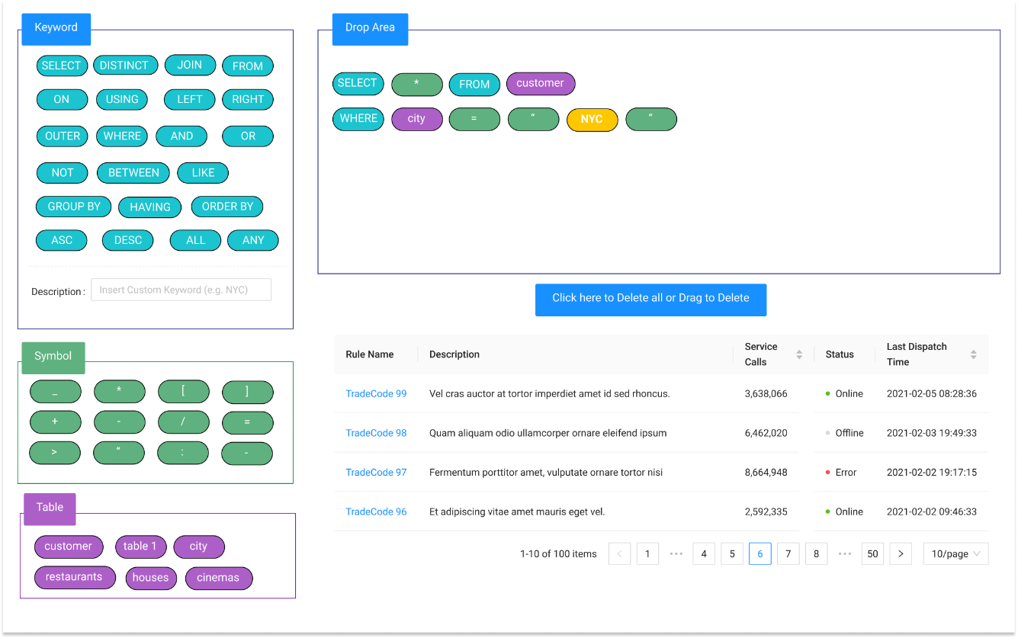

Figure 2. 1 Drag-and-Drop Model by Phewkum C.

(Reference: (Phewkum et al., 2019))

As illustrated in mockup above, the research done by (Phewkum et al., 2019) uses open-ended approach since most of the SQL Query keywords, symbols, and available tables are provided directly to the students to answer each question.

Whereas the ease-of-use aspect while answering the practices get feedbacks from the user that the system is easy to use and scored 3.56 out of 5. As stated from the journal by (Phewkum et al., 2019) that this may be due to participants’ who could touch type quickly, did not prefer a drag-and-drop settings.

The research entitled “The Different Role of Working Memory in Open-Ended Versus Closed-Ended Creative Problem Solving: A Dual-Process Theory Account” by (Lin & Lien, 2013) has concluded that when solving a scientific task, the working memory of a person is dominated by the thought of ‘how to solve the problem’ in technical approach and highly depends on the complexity of the problem itself. 40 participants in that research stated that they stuck on creating correct hypotheses and needed to revise their idea to solve the problem. In other words, if there is any case that requires some predefined syntax or formulation or rules, the thinking ability and memory capacity of the person will be fully concerned with finishing the task while considering the rules at the same time. By having a close-ended approach, the complexity level can be reduced and since the rules are predefined, participants are more resistant to syntax errors.

Previous research on literature review has indicated that a combination of drag-and-drop and learning SQL queries gives a new experience to students in database courses. There are some parts of practical implementation of past research that have the potential to be improved. Such as observing the understanding difference of database concepts based on specified testing parameters as well as the implementation of the close-ended approach in learning database courses.

## Basic Theory

## Database

A database is a collection of structured and organized data that are stored in a computer system. Database configuration can be done by using DBMS (Database Management System). Databases play an important role in information systems, such as storing and processing data [(Zhuoyi et al., 2012)](https://www.zotero.org/google-docs/?ApgPou). In its development, the database has 2 categories, namely relational database and non-relational database. The main consideration of choosing one of these is the data type, size of the data, system capability, and maintainer skills for managing the existing database.

## SQL Query

SQL Query is the most common operation to manipulate databases. This is because SQL Query is useful for analysing, storing, and retrieving data that has been processed from a database [(Borthick et al., 2001)](https://www.zotero.org/google-docs/?5qqLey). A description of the process of retrieving or manipulating the database by the user can be illustrated as follows:

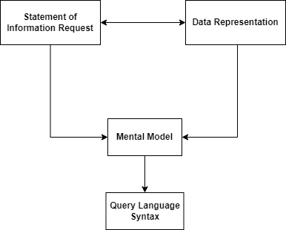

Figure 2. 2Model of end users’ query formulation processes

(Reference: (Borthick et al., 2001))

As the complexity of the query grows, a higher cognitive level of database administrators is required to make a query formula that has good performance. A commonly used approach is to use a subquery. By the top-down method, a complex problem can be analyzed and divided into some simpler problems to solve. [(Hoque et al., 2014)](https://www.zotero.org/google-docs/?89jD24)

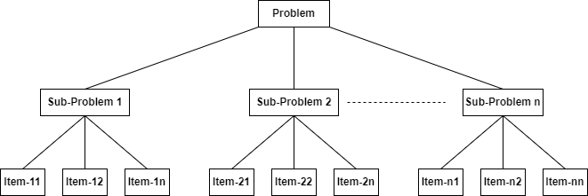

Figure 2. 2 Top-down Analysis of PBL Problem (Reference: (Hoque et al., 2014))

## Drag-and-Drop

The *drag-and-drop* operation consists of object selection, object transforming, and placing it in another place. A drag-and-drop implementation may improve user experience on certain programming activity, and a faster problem-solving process since it can reduce typing error and gives flexibility for the users to adjust code in order. [(Price & Barnes, 2015)](https://www.zotero.org/google-docs/?CB6nh7)

## Close-Ended Approach

A close-ended approach is a way for respondents or participants to choose one from multiple predefined answers based on the context of an existing problem. That way, the data retrieval process can be done quickly and easily [(Hyman, 2016).](https://www.zotero.org/google-docs/?VBsyqf) When respondents are faced with a problem using a close-ended approach, their thinking process steps start from interpreting the problem, understanding the context of the measured score, and determining the correct answer based on their respective perceptions and understandings [(Baburajan et al., 2021).](https://www.zotero.org/google-docs/?9lk5hY)

## SQLearn

SQLearn is a learning SQL platform for students to understand database concepts, specializing in query SQL. To use the application, the registered lecturer of the database subject should create questions for a class. For each question, the lecturer provides the SQL queries part required to solve the quiz or case study. These SQL parts components need to be constructed by students by dragging and dropping them to a specified place. By close-ended approach, while it is possible to make the wrong answer, the SQL parts given by the lecturer should be a huge lead for students to answer it correctly.

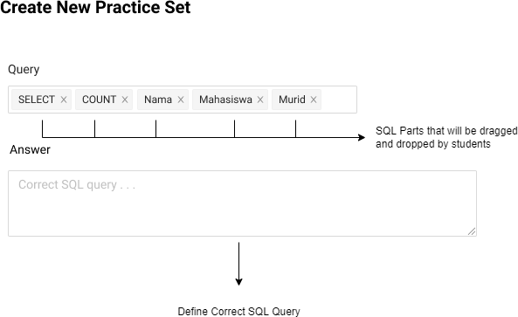

Figure 2. 3 Lecturer - Application Concept

From the students' perspective, firstly the students need to choose the class and quiz created by their lecturer, Then, they are required to construct a valid SQL query to answer the question based on options available by dragging and dropping it. In its process, students are allowed to check and validate their constructed SQL queries by clicking 'Check Query'. If they are confident enough, they can just click 'Submit' directly. Based on the previous explanation, the application concept of SQLearn is illustrated as follows:



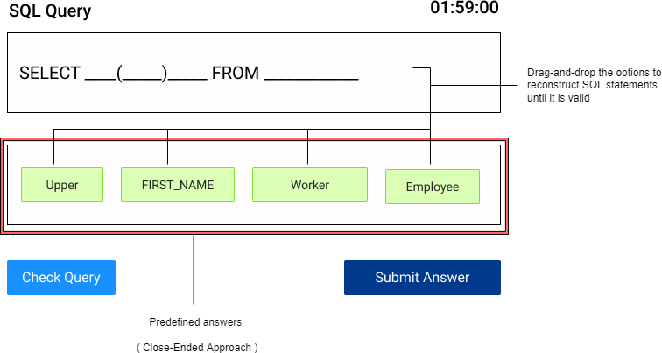

Figure 2. 4 Students - Application Concept

This application complements the idea of past researches regarding the SQL Learning Platform that uses conventional approach, not overrides nor replacing it. This application role can be an alternative for the lecturers to give variation on form of question which will be given to the students for practices. While for the student, they can get new experience while answering a specific problem with predefined answers (close-ended approach).

# CHAPTER III. RESEARCH METHODOLOGY

## Time and Place of Research

The research will be conducted in State Polytechnic of Malang and will be held for 4 months from January 2022 until April 2022.

## Data Collection

Data that will be used in this research is students’ score results after practicing SQL query case studies. Moreover, while the students are dragging and dropping, the system will collect their activity log. This activity log includes:

1. Time spent on solving a case study
2. Number of attempts while checking query
3. Constructed SQL Record with timestamps

But for this research purpose, the activity log is collected and will not proceed to processing the activity log any further.

## Field Research

Interview with one of the lecturers that teaches database subjects in Information Technology Major State Polytechnic of Malang to get accurate information. The author will provide some questions regarding the database teaching style for the SQL Query chapter, especially in the SELECT statements. The result of the interview will be analyzed and used to formulate a better close-ended approach and suit the learning flow of database subjects with the student’s capability.

## Library Research

The author has performed literature reviews from journals and articles regarding the key problem that will be discussed to get a theoretical basis and gather some insights on approaches being used in previous research.

## Data Processing

In this research, the data processing will use the T-Test independent method to observe the comparison of pre-test and the post-test result of students’ after using drag-and-drop on SQL query practices in SQLearn application.

## System Design

## Use Case Diagram

### **3.4.1.1. Student**

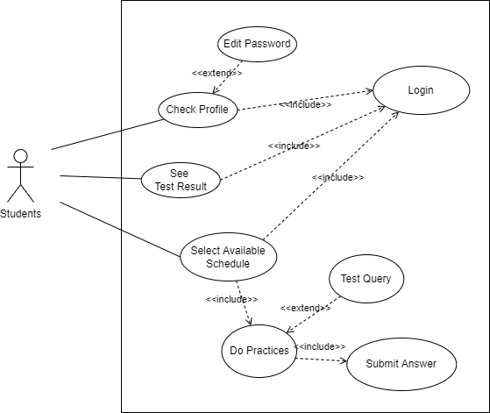

Figure 3. 1 Use Case Diagram - Student

As illustrated in the above diagram, students are able to check their profile, see how’s their performance in each practice by accessing test result page, and select available schedule to do the practices. As for the practice itself, students have option to check their query, this action will be recorded and being used in assessment by counting how many attempts they checked their query. After done, they need to submit the answer.

### **3.4.1.2. Lecturer**

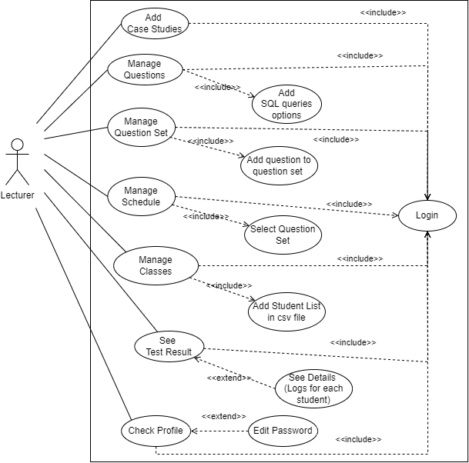

Figure 3. 2 Use Case Diagram - Lecturer

As illustrated in the above diagram, the lecturers are able to do things that are related to creating questions and more. After logged in to the system, lecturer can create a case study, manage questions, manage question set, manage schedule, manage classes, see test result, and check profile. Each has its respective action. In the process of creating a question, lecturer need to add SQL Queries options to define the category to close-ended.

### **3.4.1.3. Admin**

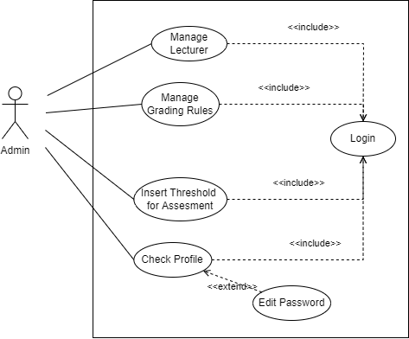

Figure 3. 3 Use Case Diagram - Admin

As illustrated in the above diagram, admins are responsible of managing the lecturer, the grading rules, threshold assessment, and check their own profile. The grading rules are used for validating how many attempts student has performed while checking their query. Whereas the threshold is used for automation assessment process.

## Application Activity Diagram

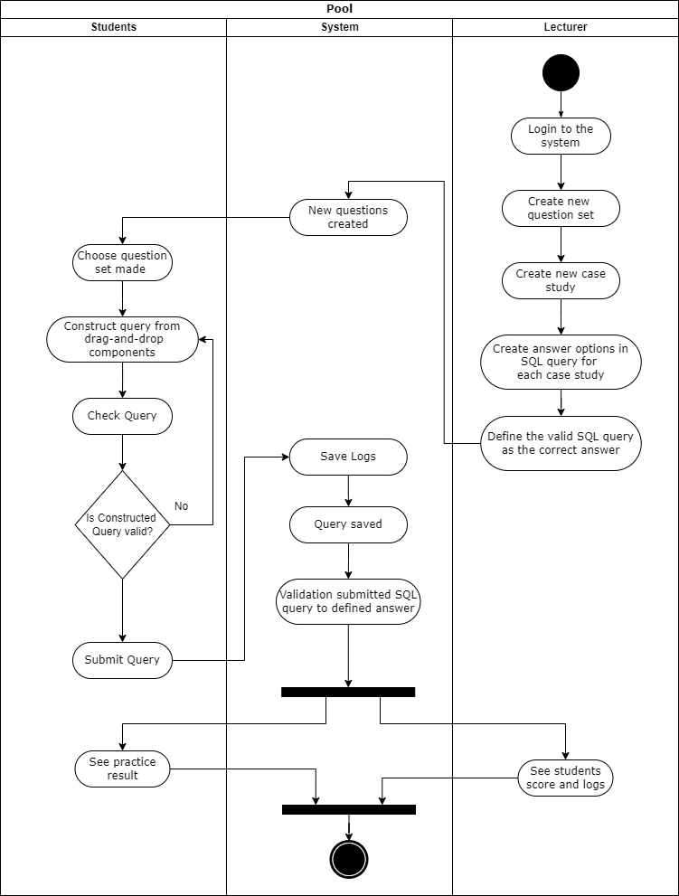

Figure 3. 4 Activity Diagram of SQLearn

To have access to SQLearn, both lecturers and students need to be registered and logged in with their credentials. As for this research, and to make the testing phase more seamless, it is recommended for lecturers to set their credentials with their NIDN. Whereas students are expected to set their credentials with NIM.

To make this application usable, lecturers should make the question sets first. Each question set has a one-to-many case study. For each case study, the lecturer should

define the SQL query options and their valid answer. While the valid answer is the constructed SQL query, These SQL query options will then be represented as drag-and- drop components in the students’ menu.

For students, SQLearn is the playground to practice their SQL query for SELECT statements. After their respective lecturer in the database subject has added question sets, students are allowed to do the practice. In their dashboard, they will have a menu that redirects them to the available question sets. To finish the practice, they should solve the case study by drag-and-drop from the provided SQL queries by their lecturer. In the process, they can either test their constructed query first to check its validity, or just directly submit the SQL query to the system and proceed to the next case study.

Once the question sets are all answered by the students, the system will check and validate submitted SQL queries to the defined answers in the lecturer's role. When it is done, both roles are expected to get the result in their dashboard. For the students, the result will be the final score. Whereas for the lecturers, the result is the final score of students that have finished a specific question set.

## Application Features

* + - * Register

Students and lecturers can register. By creating an account in the system, they will be allowed to log in and use SQLearn features. Lecturers are expected to set their credentials with NIDN. Whereas students’ set their credentials with NIM.

* + - * Login

Students and lecturers can log in to the system. Each role has specified features. Lecturers’ login with their NIDN as their username and password. For students, they login with their NIM.

* + - * Create Questions

This feature is limited to the lecturer’s role only. In this feature, the lecturer will need to create some questions for students’ practice in a case study format. In addition, the lecturer needs to specify SQL Statements as the drag-and-drop component in students’ roles.

* + - * Practice SQL Query

This feature is limited to the students’ roles only. Students are allowed to have practice on questions provided by their respective lecturer in the database subject. To finish the practice, students will need to construct the query based on the SQL components given.

* + - * Practice Result

Students and their respective lecturers in database subjects will have access to view the score of the practice and how is the student’s performance on constructing SQL queries.

## Application Mockups

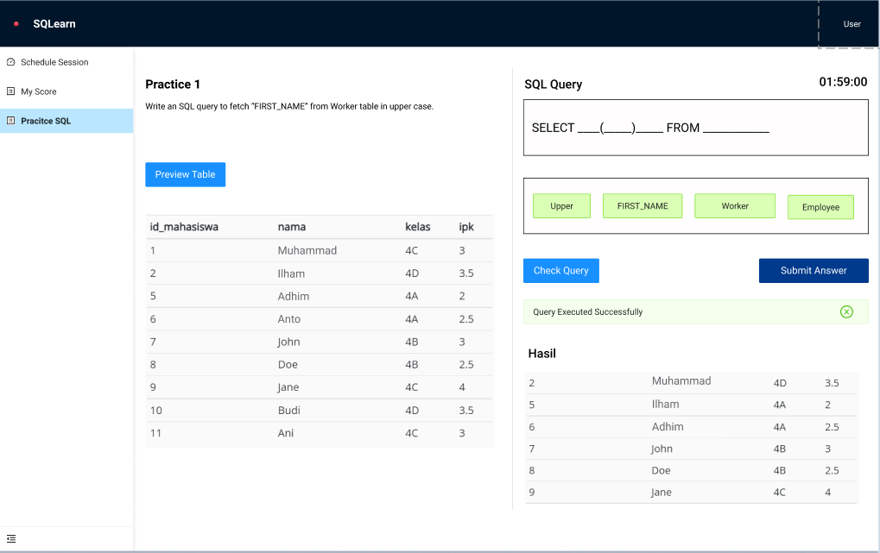

Figure 3. 5 Mockup - Students submit the correct query

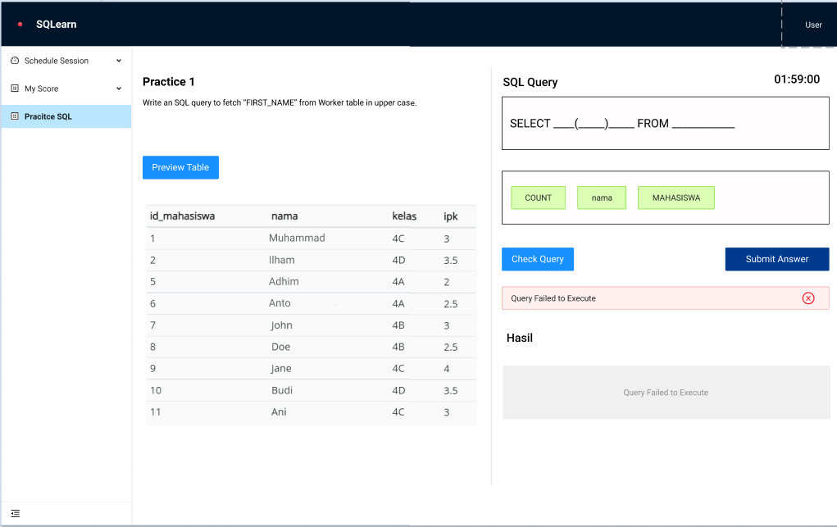

Figure 3. 6 Mockup - Students submit the wrong query

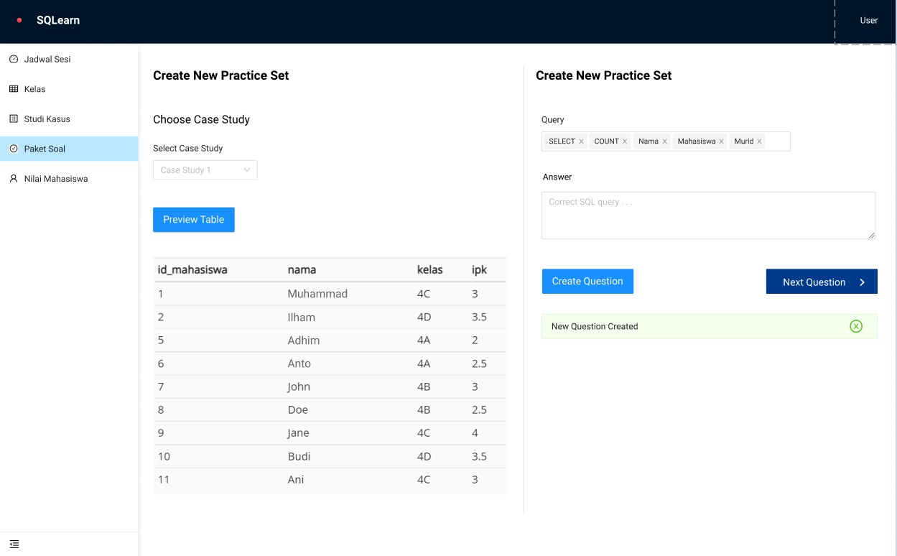

Figure 3. 7 Mockup - Lecturer create new practice

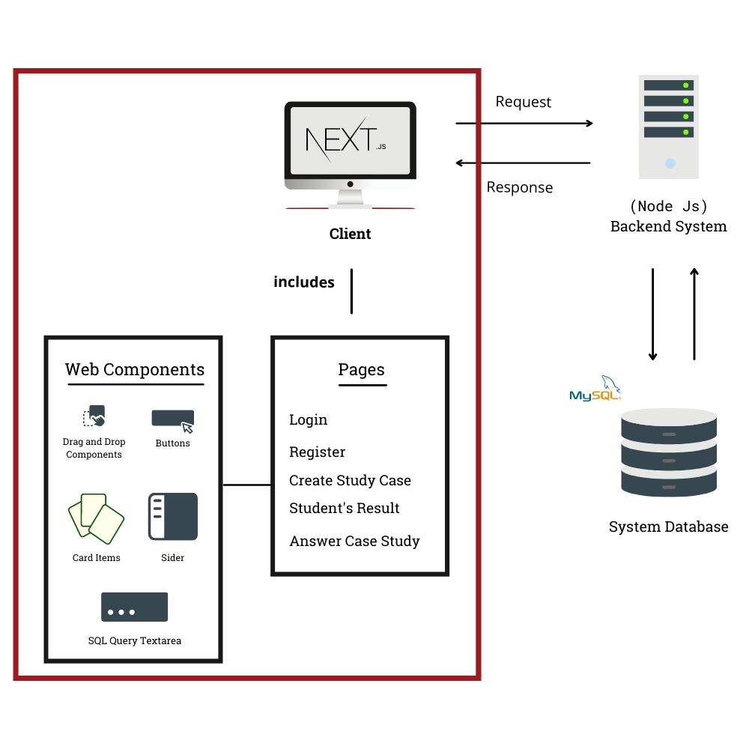

Figure 3. 8 System Architecture of SQLearn

As an effect of having multiple case studies in one system, the usage of multiple databases included in SQLearn is inevitable. Such databases are also divided into case-study databases and the system database. With Node JS serving the backend process, it is expected to have multiple ORMs as well. The backend system will handle authentication, SQL query validation, and processing other data.

As for the frontend, Next JS is an open-source framework that utilizes React JS which is a JavaScript library that allows the developer to create web components to build the user interface of the SQLearn web application. Each component has its roles and is independent to each other. With this component approach in building a website, it is also possible to have a component that can be dragged and dropped.

## System Testing

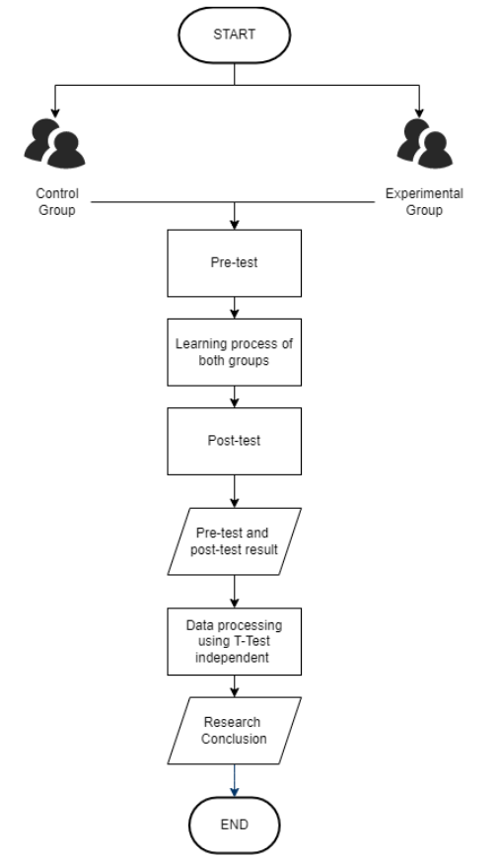

The participants of this experiment will be students that have finished or are taking a database course in Information Technology department State Polytechnic of Malang.

Pre-test and post-test experiments will be conducted. Both tests divide the research’s participants into 2 groups. One group will use SQLearn, and the other won’t use SQLearn

– they will be asked to solve defined case studies solely depending on job sheets and official database courses given by lecturers –. The group that uses SQLearn is the *experimental group* whereas the other group (control *group)* will use jobsheets.

For the *experimental group*, after solving the case studies, the system will record the activity log when the students trying to solve the problem. In this research, these activity logs are purposed to be collected only. And gives room for improvement to be used and processed on further research.

To determine students understanding, the entity that will be considered is the score of both pre-test and post-test in both groups. Considering the data observed will be both of the test results, and the participants of this research will be categorized into two groups, The research data will be processed using independent T-Test method. After that, it can be concluded whether the research objective is fulfilled or not by observing the usage of the drag-and-drop concept with a close-ended approach in students understanding of database subjects, especially in constructing SQL statements.

# CHAPTER IV. RESEARCH TIMELINE

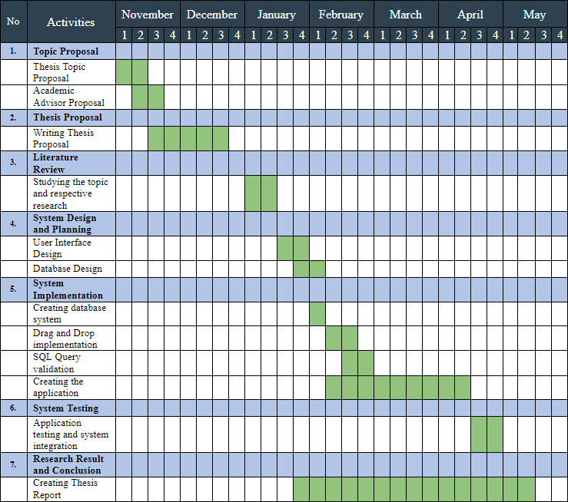

Table 1 Research Timeline

# REFERENCES

[Ahadi, A., Prior, J., Behbood, V., & Lister, R. (2015). A Quantitative Study of the Relative Difficulty](https://www.zotero.org/google-docs/?zoRcNn) [for Novices of Writing Seven Different Types of SQL Queries. *Proceedings of the 2015 ACM*](https://www.zotero.org/google-docs/?zoRcNn)[*Conference on Innovation and Technology in Computer Science Education*, 201–206.](https://www.zotero.org/google-docs/?zoRcNn) [https://doi.org/10.1145/2729094.2742620](https://www.zotero.org/google-docs/?zoRcNn)

[Ali, A. M., Tumian, A., & Abu Seman, M. S. (2017). A conceptual approach for understanding](https://www.zotero.org/google-docs/?zoRcNn) [computer programming skills development. *2017 International Conference on Research and*](https://www.zotero.org/google-docs/?zoRcNn)[*Innovation in Information Systems (ICRIIS)*, 1–5.](https://www.zotero.org/google-docs/?zoRcNn) [https://doi.org/10.1109/ICRIIS.2017.8002526](https://www.zotero.org/google-docs/?zoRcNn)

[Baburajan, V., e Silva, J. de A., & Pereira, F. C. (2021). Open-Ended Versus Closed-Ended Responses:](https://www.zotero.org/google-docs/?zoRcNn) [A Comparison Study Using Topic Modeling and Factor Analysis. *IEEE Transactions on*](https://www.zotero.org/google-docs/?zoRcNn)[*Intelligent Transportation Systems*, *22*(4), 2123–2132.](https://www.zotero.org/google-docs/?zoRcNn) [https://doi.org/10.1109/TITS.2020.3040904](https://www.zotero.org/google-docs/?zoRcNn)

[Bennedsen, J., & Caspersen, M. E. (2007). *Failure Rates in Introductory Programming*. 5.](https://www.zotero.org/google-docs/?zoRcNn)

Bergin, S., Reilly, R., & Traynor, D. (2005). Examining the role of self-regulated learning on introductory programming performance. Proceedings of the 2005 International Workshop on Computing Education Research - ICER ’05. doi:10.1145/1089786.1089794

[Borthick, A. F., Bowen, P. L., Jones, D. R., & Hung Kam Tse, M. (2001). The effects of information](https://www.zotero.org/google-docs/?zoRcNn) [request ambiguity and construct incongruence on query development. *Decision Support*](https://www.zotero.org/google-docs/?zoRcNn)[*Systems*, *32*(1), 3–25. https://doi.org/10.1016/S0167-9236(01)00097-5](https://www.zotero.org/google-docs/?zoRcNn)

[Cheung, J. C. Y., Ngai, G., Chan, S. C. F., & Lau, W. W. Y. (2009). *Filling the Gap in Programming*](https://www.zotero.org/google-docs/?zoRcNn)[*Instruction: A Text-enhanced Graphical Programming Environment for Junior High Students*.](https://www.zotero.org/google-docs/?zoRcNn) [*41*(1), 5. https://doi.org/10.1145/1539024.1508968](https://www.zotero.org/google-docs/?zoRcNn)

[de Jong, T. (2010). Cognitive load theory, educational research, and instructional design: Some food](https://www.zotero.org/google-docs/?zoRcNn) [for thought. *Instructional Science*, *38*(2), 105–134. https://doi.org/10.1007/s11251-009-9110-](https://www.zotero.org/google-docs/?zoRcNn) [0](https://www.zotero.org/google-docs/?zoRcNn)

[Fedorenko, E., Ivanova, A., Dhamala, R., & Bers, M. U. (2019). The Language of Programming: A](https://www.zotero.org/google-docs/?zoRcNn) [Cognitive Perspective. *Trends in Cognitive Sciences*, *23*(7), 525–528.](https://www.zotero.org/google-docs/?zoRcNn) <https://doi.org/10.1016/j.tics.2019.04.010>

Garner, P., & Mariani, J.A. (2015). Learning SQL in steps. *Journal on Systemics, Cybernetics and Informatics, 13*, 19-24.

[Heift, T. (2003). *Drag or Type, But Don’t Click: A Study on the Effectiveness of Different CALL*](https://www.zotero.org/google-docs/?zoRcNn)[*Exercise Types*. 18.](https://www.zotero.org/google-docs/?zoRcNn)

[Hoque, A. S. Md. L., Bashiry, G. Md. M., & Uddin, Md. R. (2014). Equivalence of Problems in](https://www.zotero.org/google-docs/?zoRcNn) [Problem Based e-Learning of Database. *2014 IEEE Sixth International Conference on*](https://www.zotero.org/google-docs/?zoRcNn)[*Technology for Education*, 106–109. https://doi.org/10.1109/T4E.2014.23](https://www.zotero.org/google-docs/?zoRcNn)

[Hyman, D. M. R. (2016). *Open- versus Close-Ended Survey Questions*. 6.](https://www.zotero.org/google-docs/?zoRcNn)

[Jamil, M. G., & Isiaq, S. O. (2019). Teaching technology with technology: Approaches to bridging](https://www.zotero.org/google-docs/?zoRcNn) [learning and teaching gaps in simulation-based programming education. *International Journal*](https://www.zotero.org/google-docs/?zoRcNn)[*of Educational Technology in Higher Education*, *16*(1), 25. https://doi.org/10.1186/s41239-](https://www.zotero.org/google-docs/?zoRcNn) [019-0159-9](https://www.zotero.org/google-docs/?zoRcNn)

[Lin, W.-L., & Lien, Y.-W. (2013). The Different Role of Working Memory in Open-Ended Versus](https://www.zotero.org/google-docs/?zoRcNn) [Closed-Ended Creative Problem Solving: A Dual-Process Theory Account. *Creativity*](https://www.zotero.org/google-docs/?zoRcNn)[*Research Journal*, *25*(1), 85–96. https://doi.org/10.1080/10400419.2013.752249](https://www.zotero.org/google-docs/?zoRcNn)

[Luthfi, M., & Ayu, A. (2019). *A review of increasing teaching and learning database subjects in*](https://www.zotero.org/google-docs/?zoRcNn)[*computer science*. *40*, 9.](https://www.zotero.org/google-docs/?zoRcNn)

[Marion, B., Impagliazzo, J., & Clair, C. S. (2007). *Assessing Computer Science Programs: What Have*](https://www.zotero.org/google-docs/?zoRcNn)[*We Learned*. 2.](https://www.zotero.org/google-docs/?zoRcNn)

[Phewkum, C., Kaewchaiya, J., Kobayashi, K., & Atchariyachanvanich, K. (2019). ScrambleSQL: A](https://www.zotero.org/google-docs/?zoRcNn) [Novel Drag-and-drop SQL Learning Tool. *2019 23rd International Computer Science and*](https://www.zotero.org/google-docs/?zoRcNn)[*Engineering Conference (ICSEC)*, 340–344.](https://www.zotero.org/google-docs/?zoRcNn) [https://doi.org/10.1109/ICSEC47112.2019.8974815](https://www.zotero.org/google-docs/?zoRcNn)

[Phillip Garner. (2015). *Learning SQL in steps*. *13*.](https://www.zotero.org/google-docs/?zoRcNn)

[Price, T. W., & Barnes, T. (2015). Comparing Textual and Block Interfaces in a Novice Programming](https://www.zotero.org/google-docs/?zoRcNn) [Environment. *Proceedings of the Eleventh Annual International Conference on International*](https://www.zotero.org/google-docs/?zoRcNn)[*Computing Education Research*, 91–99. https://doi.org/10.1145/2787622.2787712](https://www.zotero.org/google-docs/?zoRcNn)

[Puspitasari, D., Arhandi, P. P., Saputra, P. Y., Syaifudin, Y. W., Himawan, H. A., & Sholihah, P. A.](https://www.zotero.org/google-docs/?zoRcNn) [(2019). Online judge MySQL for learning process of database practice course. *IOP Conference*](https://www.zotero.org/google-docs/?zoRcNn)[*Series: Materials Science and Engineering*, *523*(1), 012046. https://doi.org/10.1088/1757-](https://www.zotero.org/google-docs/?zoRcNn) [899X/523/1/012046](https://www.zotero.org/google-docs/?zoRcNn)

[Rith, J., Lehmayr, P. S., & Meyer-Wegener, K. (2014). Speaking in tongues: SQL access to NoSQL](https://www.zotero.org/google-docs/?zoRcNn) [systems. *Proceedings of the 29th Annual ACM Symposium on Applied Computing*, 855–857.](https://www.zotero.org/google-docs/?zoRcNn) [https://doi.org/10.1145/2554850.2555099](https://www.zotero.org/google-docs/?zoRcNn)

[Sastry, K. S. (2015). *An Effective Approach for Teaching Database Course*. 11.](https://www.zotero.org/google-docs/?zoRcNn)

[Shaw, D., Woodford, B. J., & Benwell, G. L. (2007). Educating future IS professionals through real-](https://www.zotero.org/google-docs/?zoRcNn) [world integration. *International Journal of Teaching and Case Studies*, *1*(1/2), 66.](https://www.zotero.org/google-docs/?zoRcNn) [https://doi.org/10.1504/IJTCS.2007.014210](https://www.zotero.org/google-docs/?zoRcNn)

[Taipalus, T. (2019). *A Notation for Planning SQL Queries*. *30*, 9.](https://www.zotero.org/google-docs/?zoRcNn)

Surbakti, K. (2018). Kajian Mengenai Pentingnya Basis Data Bagi Sekolah Saat Ini. Jurnal 74 Curere, 02(02), 2597–9515.

[Zhuoyi, C., Na, L., & Hongjie, Z. (2012). Exploration of teaching model of the database course based](https://www.zotero.org/google-docs/?zoRcNn) [on constructivism learning theory. *2012 2nd International Conference on Consumer*](https://www.zotero.org/google-docs/?zoRcNn)[*Electronics, Communications and Networks (CECNet)*, 1808–1811.](https://www.zotero.org/google-docs/?zoRcNn) [https://doi.org/10.1109/CECNet.2012.6201855](https://www.zotero.org/google-docs/?zoRcNn)